COMPOST IN A BOTTLE

OVERVIEW
GRADE
Pre-K-8

PLACE
Classroom / Home

DURATION
45 mins for set-up
Monitor 2-3 weeks

This in-class and at-home activity encourages students to take an active role in learning about the decomposition process. Students will produce compost through the creation of their own mini compost bin inside of a soda bottle. When the bin is active, students will observe the natural process of decomposition that will occur over several weeks.
MATERIALS
- Clear 2-liter plastic soda bottle
- Plastic tray or plate
- 2 cups of fruits/vegetable scraps cut up
- 1 cup of grass clippings and leaves
- 2 cups of dirt from outside
- 1 cup torn newspaper
- Spray water bottle
- Spoon, scissors, push pin

TEACHER PREP
- Before doing this activity with your students, consider spending time familiarizing them with the importance of reducing food waste to save natural resources. When food is wasted, water, fuel, energy resources and money that went into making the food is also wasted. Food waste is the No. 1 contributor by weight in the Franklin County Landfill at 15% of the total waste stream.
1

Microorganisms found in nature recycle our organic materials through the process of decomposition or composting. By composting our organic materials, we recycle nutrients back into the soil, save money on fertilizers, and reduce the amount of waste sent to our local landfill. If you like composting in a bottle, think about upgrading to a compost tumbler outside to make even more nutrient rich soil for your garden!

LEARNING OUTCOMES
- Students will learn about reducing and recycling food waste
- Students will learn how to turn food scraps into something beneficial for the environment.
- Students will build food-waste-friendly habits at home.
- Students will further enhance their observation skills monitoring their science experiment over several weeks.


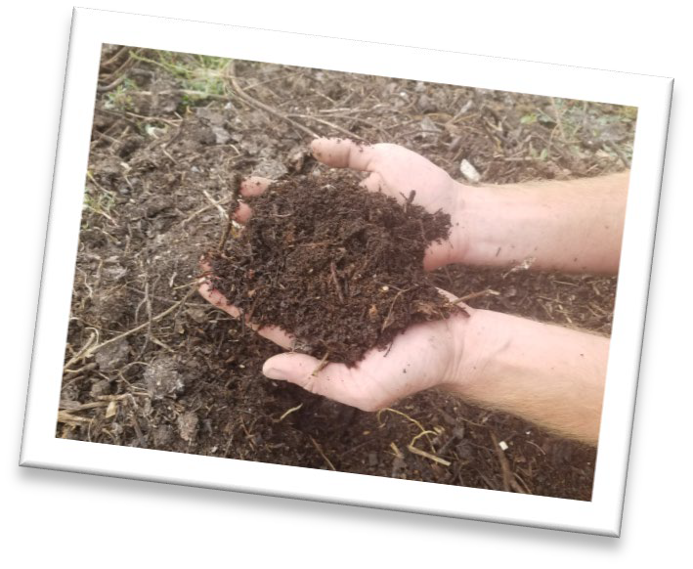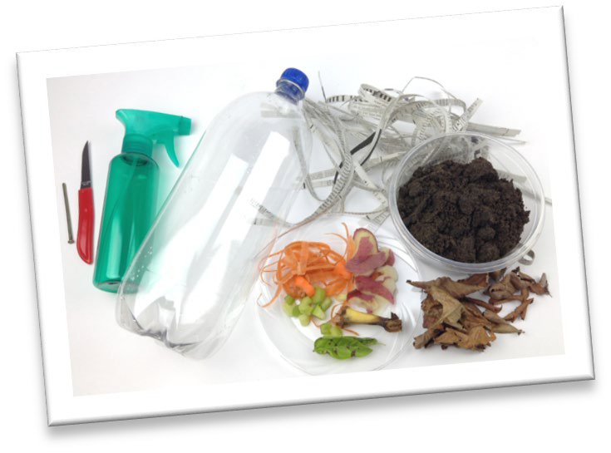
2

INSTRUCTIONS

1 | Day 1: Building the Compost in a Bottle  Step 1 -- Rinse the bottle and peel off the label. Using scissors, cut off the top two inches (below the mouth) of the bottle. Save this portion for later.  Step 2 -- Use the push pin to poke holes in the bottom of the bottle to allow air to flow through. This helps with the decomposition process. Step 3 -- In the bottom of the bottle, place 2" of soil, leaves and newspaper. Do not compact the soil. Spray the soil & leaves with the spray bottle; do not saturate the contents.  Step 4 -- Place food scraps and grass clippings on top of the soil.  Step 5 -- Place the compost in a bottle on the plastic tray so it doesn't leak and put near a window where it will get direct sunlight.  Step 6 -- Put the cut off bottle top upside down on top of the composter so It will act like a funnel when watering the composter.
2 | Day 2-14:  Each day water the compost with the spray bottle and stir around the contents to allow the bacteria to find new food to break down. This represents the turning that would ordinarily occur in a back-yard compost pile and allows air and moisture to circulate through the soil and scraps. When you are not using the composter, place a kitchen towel on top of it to prevent mold growth.  Discuss with the students what they observe each day.  - What materials decomposed the fastest? The slowest?  - What would happen If the content of the bottle were not stirred?  - What would happen If there were no air holes in the bottle?  - Why was the soil added to the bottle?
3 | Day 15 or later:  Once the materials have all mixed together and look like soil (finished  compost), you are ready to take it out of the bottle and feed to your garden or add to a pot to grow your very own plant! For further investigation: compare one plant grown with compost to another grown without. Compare the effects your compost has!

