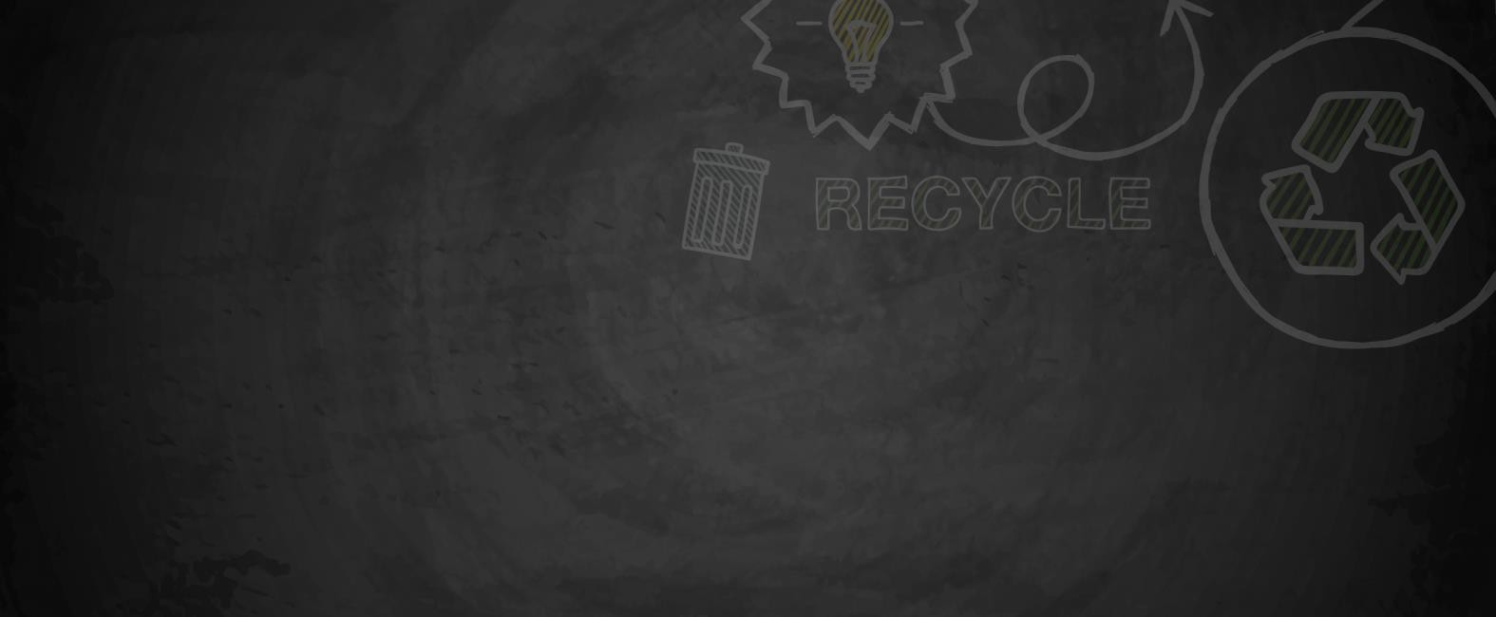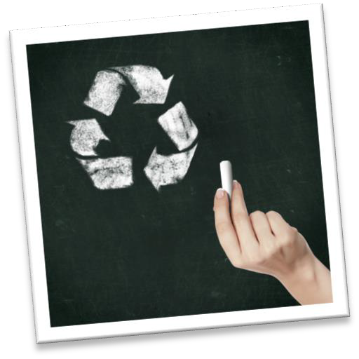

GRADE
1st – 12th & institutions of higher learning

PLACE

DURATION
30 minutes

HOW CAN I HELP?

Classroom / Home

OVERVIEW
Environmental Impact: MY HOME, MY STATE, MY COUNTRY, MY WORLD.
Even the littlest things you do can have a big impact on the environment around your home and throughout the world. You’ll find that the changes you make in your daily life not only affect you, but also improve the life of the people, plants, and animals that share our Earth.
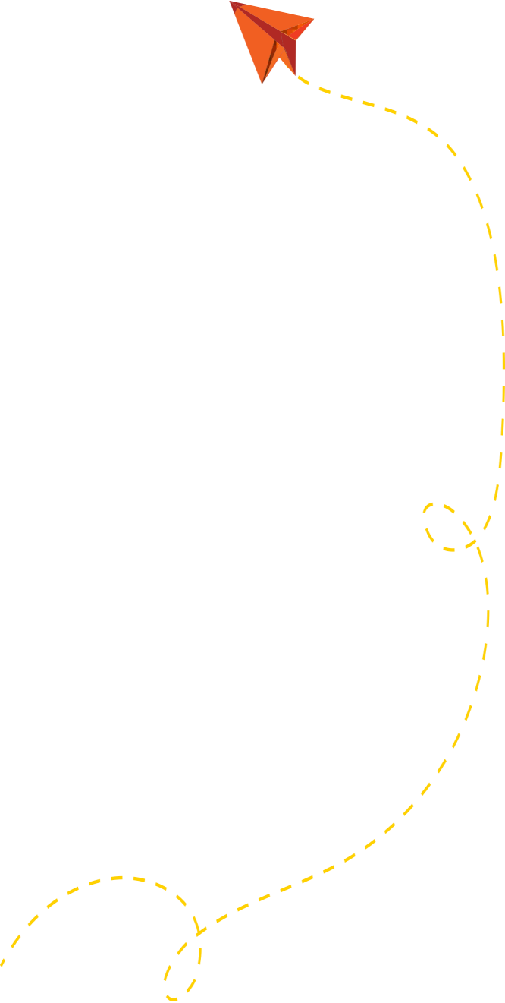
TEACHER TIPS
Teachers may want to speak to the class beforehand to discuss why it's important to help protect our environment and how they can get involved. Encourage students to start off small by incorporating 1 or 2 new habits into their daily lives.
Remember, "We don't need a handful of people doing sustainable living perfectly. We need millions of people doing it imperfectly."
-Anne Marie Bonneau at Zero Waste Chef.

1

LEARNING OUTCOMES
- Students will learn how they can contribute to a healthier environment at the home, state, country and world level.
- Students will learn that each one of them has an important role to help make a difference in the environment.

My Home

Below are some ideas of how you can help the environment without leaving the comfort of your own home and yard.

- Turn the water off when brushing teeth.
- When not in use make sure the TV, lights, and computer are turned off.
- Recycle items like paper, cardboard, plastic bottles, glass bottles and jars, aluminum cans and carton containers.
- Compost organic waste. It reduces the amount of landfill space used and creates a wonderful fertilizer for household plants and gardens.
- Dispose of household hazardous waste properly. Visit SWACO's website to learn more!
- Plant native species in landscaping.
- Provide food and shelter for bids and other wildlife.
- Don’t use pesticides and herbicides; find natural alternatives.
- Mulch gardens to conserve water.
- Return emptied plastic pots and trays to local nurseries to be reused.
- Replace incandescent light bulbs with energy efficient LED’s.
- Buy earth friendly art supplies like bee’s wax crayons, recycled paper, and water-based paint markers, and glue.
- Buy rechargeable batteries.
- Conserve water by checking toilets and sinks for leaks.
- Save energy by replacing furnace air filter often.

My State
Ready to stretch your conservation efforts beyond your home and yard? Consider participating at the state level.

- Adopt a road or highway.
- Write to state legislators about your environmental concerns.
- Visit state parks to learn more about local habitats.
- Don’t let the car idle.
- Walk, bike or take the bus instead of driving a car.
- Support local businesses that try to make an environmental difference.

- Volunteer with state conservation organizations.
- Learn what species of plants and animals are endangered in your state and what you can do to help protect them.
- Adopt an animal as a class or with some friends.
- Organize a “Litter Drive” at school. Visit a park or playground and make a difference by picking up litter.
- As a class, write to textbook publishers and ask them to print on recycled paper.
- Start a school recycling program. Visit SWACO's website to learn more!

My Country
Are you ready to help even more? See what you can do to improve the environment across the county.

- Join conservation organizations.
- Write to the president of the United States of America and let him know that the environment is important to you.
- Visit National Parks and donate.
- Learn more about the environmental issues that affect our country. Visit the Environmental Protection Agency website!

My World
We all share this earth and we need to work together to keep it clean. See what you can do worldwide to help the earth.

- Learn about the environmental problems in other parts of the world.
- Learn about the production process of the products you purchase that may have harmful environmental impacts on other parts of the world.
- Buy products made In the U.S.A.
- Support conservation organizations that protect the environment worldwide.


ACCEPT THE CHALLENGE TODAY!



