Directions
1. Take a strip of triangular shaped magazine paper, starting with the big end of the triangle roll onto the straw (refer to picture). The beads will be as wide as the base of the triangle, so keep that in mind when selecting different sizes. For example:

Large Bead
Small Bead

2. Place the straw at the base of the triangle. Place glue above straw on the paper to help hold the paper bead in place while rolling. Refer to Step 1 picture
3. Wrap the paper around the straw and roll up towards the top of the triangle. If you wrap too tightly you won’t be able to get the bead off and if it’s too loose the bead won’t stay together. You may want to experiment a little. Refer to Step 2 picture
4. When you have about an inch left, put the glue on the tip of the triangle and continue rolling to complete the bead. Step 3 picture
5. Spread any excess glue across the bead for extra security. It will help hold the paper in place.
6. Let the glue dry for about a minute then gently pull the bead off the straw. Step 4 picture
7. Repeat until you have all the beads you need for your bracelet or necklace. Feel free to supplement with plastic, wood or other beads for additional colors.
8. Slide the beads over the string and tie off a knot so the beads don’t slip off. Wear your cool new recycled jewelry to show to all your friends! Refer to Step 5 picture.
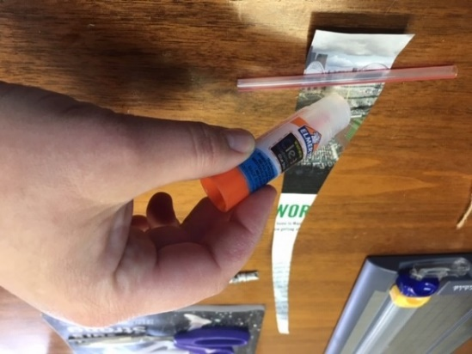
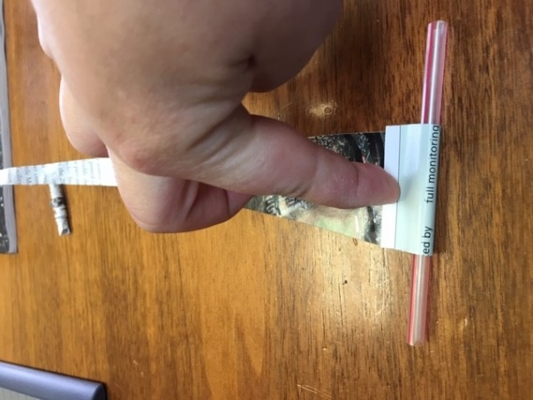
Step 1
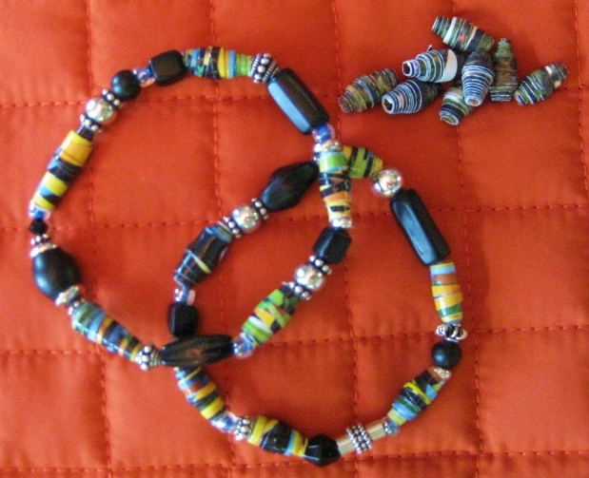
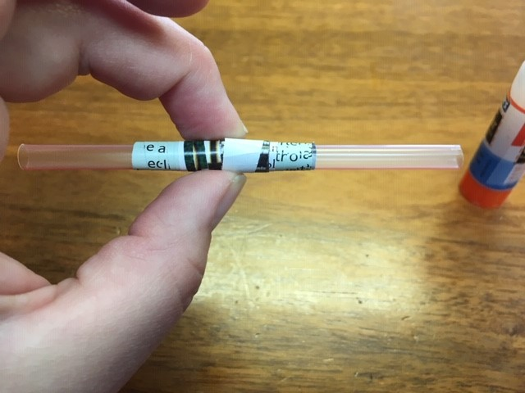
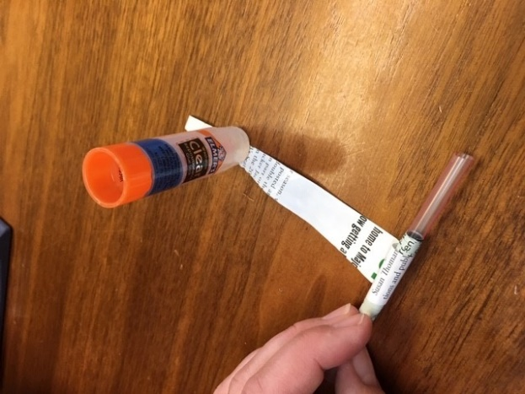
TADA! You have a beautiful and unique paper bead bracelet.
Step 5
Step 4
Step 3
Step 2

