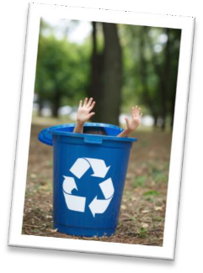

RECYCLE RIGHT BIN SORT
Now that you know what you can recycle in Franklin County, you’re one step closer to becoming a recycling champion! If you need a reminder, please go to recycleright.org.
Sort each item into the correct bin; the fewer items in the landfill bin, the better for the environment! Remember, some items can go in more than one bin.

Items:
Glass bottle Magazine Cardboard Banana peels
Aluminum can Vegetable scraps Diapers Paper towels
Plastic bags Newspaper Styrofoam Straws
Shoes Clean pizza boxes Fast food cups Meats
Toys Eggshells Milk jugs Plastic bottles

REUSE RECYCLE COMPOST LANDFILL

____________ _____________ _____________ ____________

_____________ ______________ ______________ _____________

____________ _____________ ______________ ____________

_____________ ______________ ______________ ____________

_____________ ______________ ______________ ____________

