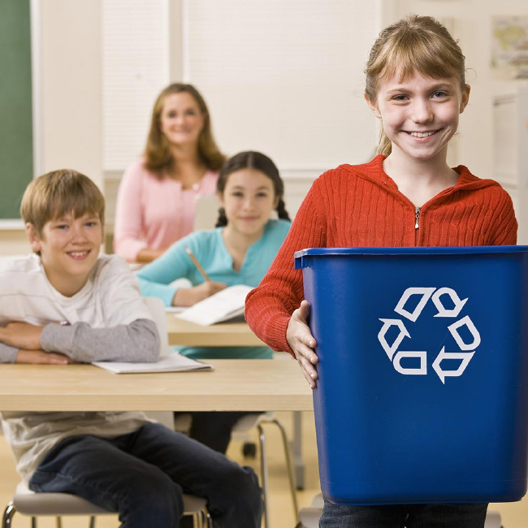
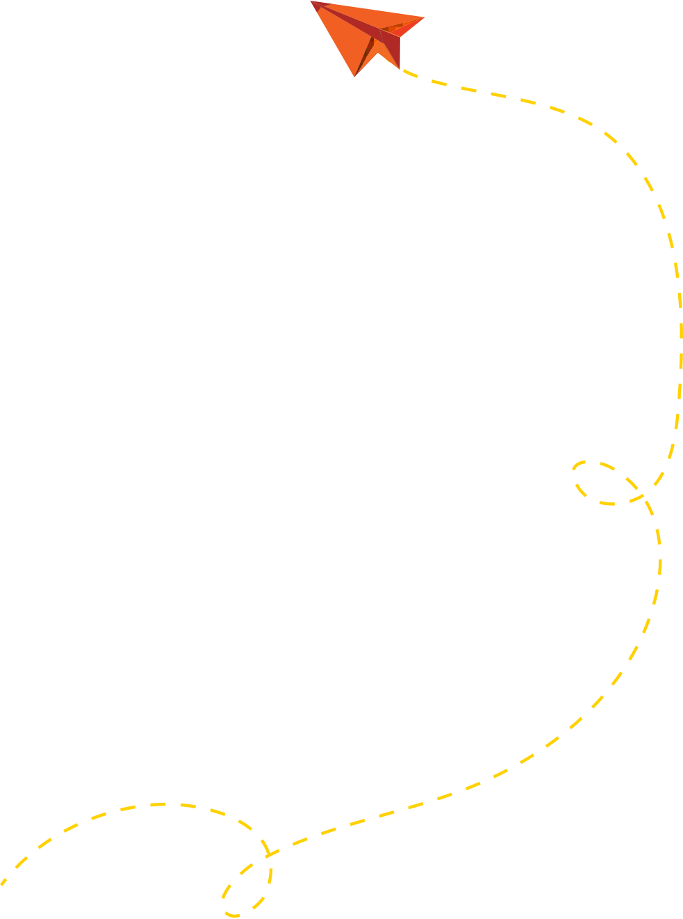


OVERVIEW
Students will learn about the importance of recycling right at school or at home. The Recycling Relay Race is a non-competitive relay where students can examine various items and determine how to sort them in the appropriate bin. This activity can easily be adapted for kids at home to play as well! Begin with making sure your students know why it's important to dispose of materials in the right way and why some materials should be recycled, rather than just thrown away. They should know that recycling is the process of taking an item and making it into another item thereby conserving natural resources, reducing pollution, and diverting materials from the landfill. Please refer to the image below (in additional resources) and/or go to recycleright.org to confirm what is accepted for recycling in Franklin County.

Recycling relay race

LEARNING OUTCOMES
- Students will learn the concepts of rethinking, reducing, reusing, recycling, and their importance as materials management options.
- Student will identify personal responsibility.
- Students will learn what is accepted for recycling in central Ohio.
- Students will learn how to work cooperatively in a team.
30 minutes
5 - 18 years
Classroom / Home

PLACE

AGE

DURATION

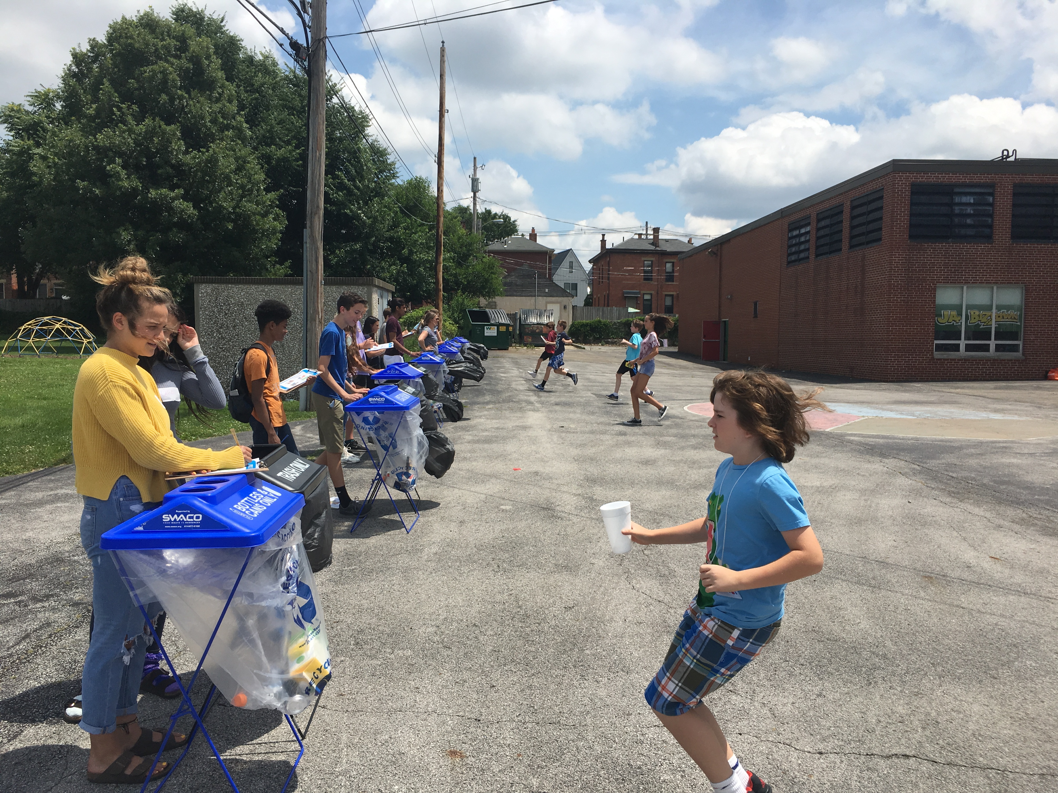
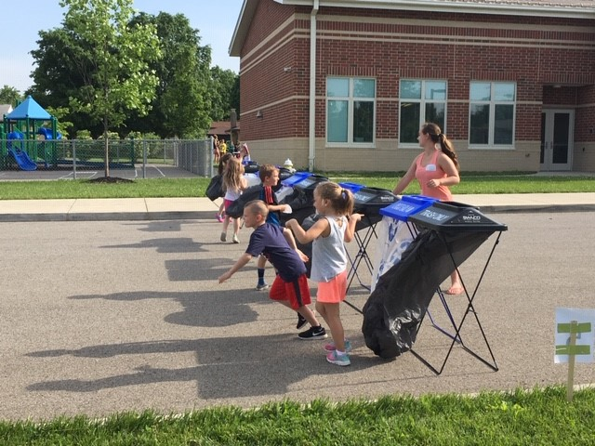
INSTRUCTIONS

MATERIALS
- 5 pieces of clean recyclables without sharp edges for each team: water bottles, paper, juice cartons, metal cans, etc. (no glass)
- 5 pieces of clean trash items without sharp edges for each team: straws, yogurt containers, snack wrappers, Styrofoam, cups, etc.
- Each team should have a recycling container
- Each team should have a trash container

TEACHER PREP
- Review what items can and can't be recycled in Franklin County at recycleright.org. By recycling right, we can help to reduce pollution, contribute to clean water, conserve limited natural resources and reduce central Ohio's reliance on landfills.

- Lorem ipsum dolor sit amet, consectetuer adipiscing elit, sed diam nonummy nibh euismod tincidunt ut laoreet dolore magna aliquam erat volutpat.

  1 | Go to recycleright.org with students and take the quiz to test your knowledge prior to playing the relay race. Discuss answers with students. If time allows, watch the video from a local recycling facility to learn more about the sorting process.
2 | The relay race works best in a gym or playground where there Is ample space for the kids to run. Make sure each team has a waste station: 1 recycling bin & 1 trash bin. Set the waste stations 20 ft. or more from the starting line. Each team's bins should be 5 ft. away from each other to prevent confusion.
3 | Each team receives a bag filled with mixed items such as: Styrofoam, plastic cups, cardboard, wrappers, plastic film, straws, metal cans, etc. Maintain similar types of quantities in each bag for fairness and consistency.
4 | Once you say, "Go" have the students dump the contents of the bag and discuss as a team which item should go in which bin. Each student runs the relay with 1 item at a time and returns to the team to tag the next person in line. Only 1 person from each team should be running the relay at a time.
5 | If possible, have a volunteer at each waste station monitoring the sorting process and tallying up the correct placements. Each team receives 1 point for each item placed in the correct bin. No points are taken away for incorrect placement.
6 | The team with the highest number of items placed in the correct bin is the winner. Go over the commonly missed items as a class. Mix up the bags and give each team a new bag of materials to play again. See if they do better the 2nd or 3rd time around!

KEY TERMS

- Rethink - it’s not enough just to put recyclables in the bin; you must rethink about what you can do to root out unnecessary wastefulness. Think about items that you are purchasing and ask yourself “Is this product over packaged? Is it made from recycled-content? Is it repairable? Is it accepted for recycling?” If the answer is “No” to any of these questions, you should Rethink the purchase.
- Reduce - A process of elimination that involves diminishing the amount of waste produced to eliminate the generation of wasted materials.
- Reuse - Reuse can be practiced easily by reusing an item over and over again. You can breathe new life into many common household objects by discovering new and innovative ways of reusing them. Before you throw it away, take a moment and learn useful tips that will allow you to repurpose and reuse numerous items found in your home.
- Recycle – The act of collecting and separating materials and products from the solid waste stream and reusing them as raw materials in manufacturing processes. Remember: you’re not truly recycling until you buy recycled goods! By purchasing recycled-goods you are helping to close the recycling loop.
- Natural Resource – Material extracted from nature, not made by humans. Material such as: ores, plants, animals. The source of all consumer products made of paper, plastic, steel, aluminum, glass, etc.
- Consumer - A person who purchases goods and services for personal use.
- Product Life-cycle Analysis – A method of accounting for all of the environmental impacts from a single-product.
- Throw-away society - The throw-away society is a human society strongly influenced by consumerism. The term describes a critical view of overconsumption and excessive production of short-lived or disposable items over durable goods that can be repaired.
- Circular Economy – A regenerative system In which resource Input and waste, emission, and energy leakage are minimized by slowing, closing, and narrowing energy and materials loops; this can be achieved through long-lasting design, maintenance, repair, reuse, remanufacturing, refurbishing, recycling, and upcycling. A circular economy contrasts a linear economy, which Is a 'take, make, dispose' model of production.
- Renewable Natural Resource – Renewable natural resources can grow again or never run out. They can be replenished fast enough as being used.
- Non-renewable Natural Resource – Nonrenewable natural resources can run out or be used up. They usually come from the ground and cannot be readily replaced by natural means on a level that Is equal to consumption.

ADDITIONAL RESOURCES

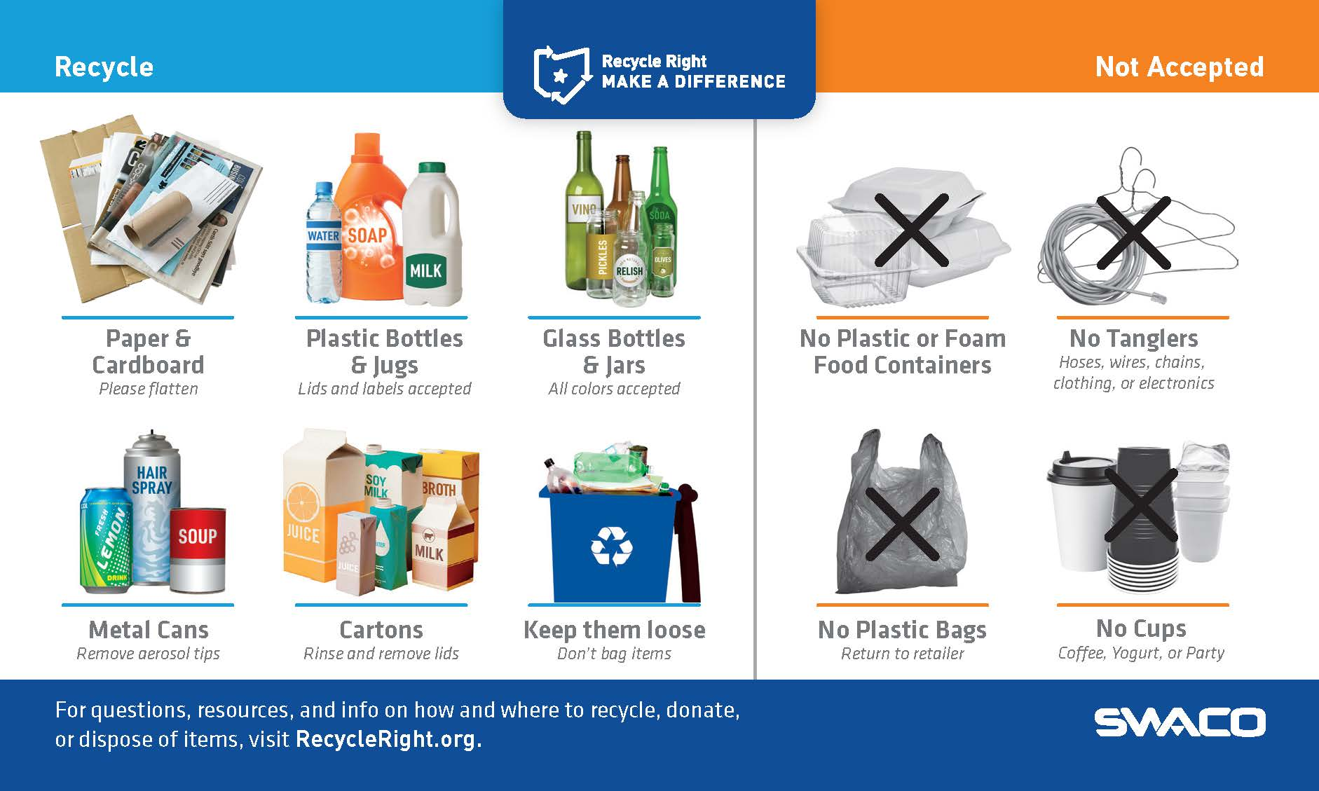

extension activities
Personal Waste Inventory student activity - students track their waste for 1 week and then sort.
Home Recycling Questionnaire student activity - students take the questionnaire home to discuss with parents.
Please download both on SWACO's School Recycling Resources webpage under Teacher Lesson Plans and Student Activities.

